2014-2015

Master Erasmus Mundus on Computational Mechanics
Master de Mètodes Numèrics en Enginyeria
Master en Enginyería Civil:

COMPUTATIONAL SOLID MECHANICS

ASSIGNMENT # 1

PART I (rate independent models):

- Implement in the supplied MATLAB code the integration algorithms (rate independent and plane strain case) for:

- The continuum isotropic damage “non-symmetric tension-compression damage” model.
- The “tension-only” damage model.

- Implement the following cases for each of those models:

- linear and exponential hardening/softening (H<0 and H>0)

- Assess the correctness of the implementation: for each of the models in section a) obtain the path at the stress space and the stress-strain curve, corresponding to appropriate loading paths starting at the point 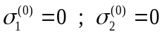 and described by three-segment paths in the strain space 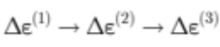. They are defined, in terms of their corresponding effective stress increments , as:

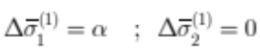 (uniaxial tensile loading)
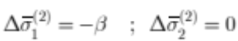 (uniaxial tensile unloading/compressive loading)
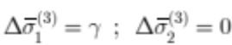 (uniaxial compressive unloading/ tensile loading)

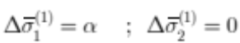 (uniaxial tensile loading)
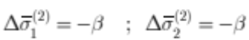 (biaxial tensile unloading/compressive loading)
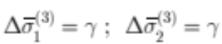 (biaxial compressive unloading/tensile loading)

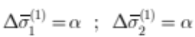 (biaxial tensile loading)
(biaxial tensile unloading/compressive loading)
(biaxial compressive unloading/tensile loading)

PART II (rate dependent models):

- Implement in the supplied MATLAB code the integration algorithm (plane strain case) for the continuum isotropic visco-damage “symmetric tension-compression” model.

e) Assess the correctness of the implementation: consider the following cases (for a specific given Poisson ratio and linear hardening/softening parameter):

- Different viscosity parameters 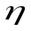.
- Different strain rate,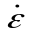 , values.
- Different 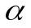 values: 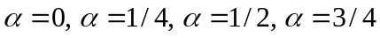 and 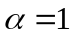 (for the time-integration method)

Obtain results displaying:

- The effects of the previous values on the obtained stress-strain curves in appropriate loading paths.
- The effects of the values, on the evolution along time of the 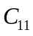 component of the tangent and algorithmic constitutive operators.

- Write a report (MAXIMUM 15 PAGES), presenting the most relevant features of the obtained results, by means of representative plots and the corresponding text. Include the modified routines as an annex (not included in the 15 pages).

GUIDELINES FOR WRITING THE ASSIGNMENT (IMPORTANT):
- The assignment grading will be done on the basis of:
- Technical aspects of the report: show that a correct implementation of the requested features has been done and assessed.
- The ability shown by the student for the scientific written communication: the balance of completeness and conciseness, the appropriate structure of the content and the selection of the assessment tests to prove the correctness of the implementations.
- The clearness of the presentation: balance and complementarity of text and graphics.
2) Do not include repetition of class notes (the one who grades the assignment already know the theory).
3) Maximize the graphic presentations power: labels of curves should be clearly marked. Captions of figures should help to understand their contents. Pay attention to the size of labels in figures to be subsequently reduced (“if it cannot be read it cannot be graded”)
4) Be aware that “the easier is the grading the higher is the mark”

